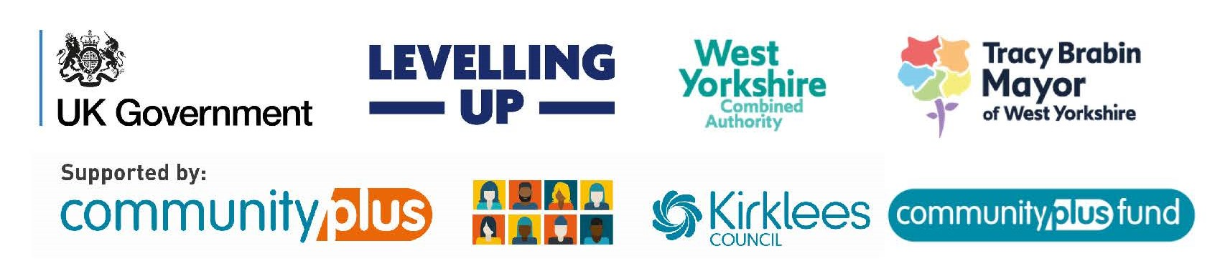
Application Form
Our grants support community-led Kirklees projects which are about:
- Growing community capacity (volunteering, group partnerships, filling gaps in provision)
- Connecting people in their communities
- Helping people do more for themselves
- Reducing social isolation and loneliness
- Increasing people’s self-confidence and self-esteem
- Developing skills which may lead to further training and education
Funding can be used for project costs such as volunteer expenses, marketing materials, equipment, room hire, resources for activities and contributions to staff and facilitator costs etc - for projects lasting up to 24 months
When completing this form, you must refer to our Criteria & Guidance and the Council’s Grant Conditions
Applications for grants are reviewed by Panels made up of members of the public from Kirklees voluntary & community sector and the Council. Our Panels will make decisions based on the following:
- Does it fully meet our criteria?
- Is it clear what the project is?
- Is the need demonstrated?
- Is it well-costed / value-for-money / sustainable?
- Does it evidence ability to deliver?
- Are partnerships / referrals considered?
Not all eligible bids will be successful as this Fund is always over-subscribed. The Community Partnership Manager and Community Coordinators can support you to apply but they do not have any influence on Panel decisions.
You must answer EVERY question and email your form as a Word document to: communityplusfund@kirklees.gov.uk
Our question |  | Your answer  Don’t include internet links or photographs – if you do, your application may not reach us. MAXIMUM 200 WORDS PER QUESTION
Q1
Name and address of your organisation and project title
Q2
How much funding are you applying for? Round up to the nearest pound

Q3
WHEN will your project start and finish? Can be up to 24 months
Q4
Two key contacts
You must include:
Name / Position
Email
Mobile
Q5
Are you registered with our Grants Access Point?
If YES, what is your score?
If NO, click here to register
Registration is essential for bids over £1,000 and must be renewed if it expires during the project’s lifetime

Q6
Have you received support from TSL Kirklees?
If NO, click here for information on support they can offer

Q7  Are you willing to complete DBS checks for all project staff?  Enhanced DBS is essential if under 18s/vulnerable adults are involved in the project. More info, click here |  | Note: You may be asked to produce relevant valid DBS reference numbers and expiry dates for paid staff and volunteers if your bid is successful
Q8
Is a similar project delivered in Kirklees?

Explain how you will connect with other partners or projects?
Q9
Do you receive other funding from Kirklees Council?
Have you previously benefitted from a CPF or Do Something Now grant and, if so, is this a different project?

Please add details – this will not disqualify you from CPF funding
Q10
Do you have any kitemarks or accreditations?
We recommend Q4H+W for anyone delivering health and well-being services in Kirklees
YOUR PROJECT

MAXIMUM 200 WORDS FOR EACH BOX (anything over 200 words will be deleted)
Do not send any additional documents or add internet links, only this application form will be presented to Panel

Q11
WHAT is your project and how will you deliver it?
Tell us who you are and what you want to do!

Q12
HOW will people benefit from your project?
Tell us who will benefit and how it will make a difference in the community?
Think about how many staff / volunteers / participants you hope to involve. Explain how they will be involved. Will your project reach out to any specific protected characteristic groups?
Q13  WHERE will you deliver your project?  Click on the boxes for the wards which your project will cover. Open the document in desktop for this to work. | Almondbury |  |  | ☐
 | Ashbrow |  |  | ☐
 | Batley East |  |  | ☐
 | Batley West |  |  | ☐
 | Birstall & Birkenshaw |  |  | ☐
 | Colne Valley |  |  | ☐
 | Cleckheaton |  |  | ☐
 | Crosland Moor & Netherton |  |  | ☐
 | Dalton |  |  | ☐
 | Denby Dale |  |  | ☐
 | Dewsbury East |  |  | ☐
 | Dewsbury South |  |  | ☐
 | Dewsbury West |  |  | ☐
 | Golcar |  |  | ☐
 | Greenhead |  |  | ☐
 | Heckmondwike |  |  | ☐
 | Holme Valley North |  |  | ☐
 | Holme Valley South |  |  | ☐
 | Kirkburton |  |  | ☐
 | Lindley |  |  | ☐
 | Liversedge & Gomersal |  |  | ☐
 | Mirfield |  |  | ☐
 | Newsome |  |  | ☐
Q14
WHY is there a need for your project?

What is the issue you are trying to help solve?

How do you know that things need to change?

How have you captured this information?

Q15
HOW will you promote
the project and attract participants?

Think about your target audience and consider both online (social media) and traditional marketing (flyers / posters)

Q16
WHAT challenges
might you face?

Be realistic and honest!
Q17
How will you measure and evaluate success?

What success will look like for people delivering and benefitting from your project? Also, how you will record success for your monitoring half-way and at the end of your project?
Q18
What is your plan for sustainability at the
end of your project?

How will you fund your project when the CPF money runs out?
Consent  I agree that the information supplied in this document can be shared with Kirklees Council staff, Councillors and external parties such as other VCS organisations and members of the CPF Panel Privacy Notice link |  |  | Sign & date (typed signature is accepted)
Community Plus Fund - Financial Breakdown
At the half-way monitoring stage and at the end of your project, you must supply evidence of all expenditure detailed below including pay slips, invoices, receipts, ledger print outs, bank statements etc. If you wish to change any of your spending proposal at any stage you must request this via the Community Partnership Manager, or a Community Coordination Manager and this may need Panel approval.
DIRECT COSTS: Project costs which are clearly and directly part of the project. For example, volunteer expenses, venue, vehicle or equipment hire, project materials, the salaries of specific project staff, and all other costs easily identifiable as part of the project

INDIRECT COSTS: We will make a reasonable & fair contribution towards indirect costs for the project duration. In total, this contribution cannot exceed 20% of your total bid and must be justified as reasonable. Indirect costs are overheads which are necessary for the organisation to operate, e.g., management, administration, stationery, rent, heat, lights, phone & broadband

CAPITAL COSTS: These will be considered based on project outcomes, such as larger scale and longer-term asset-related works. Competitive quotes / tenders may be required. Investment in premises is only permitted if the applicant owns the premises or has a 20-year + lease. * Repairs, refurbishments, or anything which is a landlord's responsibility will not be funded.
Item (Detail ALL planned expenditure - add as many rows as you need) | Cost
TOTAL PROJECT COST | £

